**Santander Holdings USA,**

**Inc.**



**NEW PRODUCTS/BUSINESS ACTIVITIES POLICY**

**ENTERPRISE POLICY**

Date Last Approved June 2015 Version Number 2

Santander Holdings USA, Inc. (“SHUSA”) believes that our success is grounded in our Values, which are also shared by Banco Santander, S.A. and its subsidiaries (collectively with SHUSA, “Santander”). Santander’s commitment to treat customers, colleagues and stakeholders in a manner that is *Simple, Personal and Fair* means that every action undertaken by a SHUSA Team Member is founded on *INTEGRITY, CUSTOMER COMMITMENT, PEOPLE, TEAMWORK,*

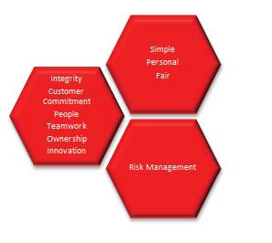

*OWNERSHIP,* and *INNOVATION*. It is because of this commitment throughout the Santander organization that Santander’s customers, clients, and shareholders trust us to deliver world class products and services and select Santander. Safeguarding this trust – by always conducting business responsibly, with integrity and a disciplined approach to risk management – is a responsibility shared by each SHUSA Team Member.

| Page 2

Date Last Approved June 2015 Version Number 2

## Table of Contents

1. INTRODUCTION 4
   1. PURPOSE OF THE DOCUMENT 4
   2. SCOPE 4
   3. DOCUMENT APPROVAL AND MAINTENANCE 4
   4. DEFINITIONS 5
2. GOVERNANCE AND ACCOUNTABILITY 6
   1. SHUSA NPBA GOVERNANCE 6
   2. SHUSA NPBA COMMITTEE 7
3. POLICY 8
   1. POLICY STATEMENT 8
   2. REVIEW AND APPROVAL PROCESS 9
      1. IDENTIFICATION 9
      2. UE DILIGENCE 10
      3. ISK ASSESSMENT 11
      4. ECOMMENDATION AND APPROVAL 11
      5. AUNCH 12
      6. MONITORING AND REPORTING 13
   3. ISSUE MANAGEMENT/ESCALATION 13
   4. TRAINING 13
4. REPORTING STRUCTURE 14
5. ROLES AND RESPONSIBILITIES 14
   1. THREE LINES OF DEFENSE 14
   2. NPBA ROLES AND RESPONSIBILITIES 15
6. EXCEPTIONS 198
7. NON-COMPLIANCE 198
8. DOCUMENT HISTORY AND VERSION CONTROL 198
   1. OWNERSHIP AND AUTHORSHIP 198
   2. SIGN OFF 198
9. APPENDICES 19

APPENDIX A. LAWS AND REGULATIONS 19

APPENDIX B. RELATED POLICIES, PROCEDURES, AND OTHER DOCUMENTS 19

Date Last Approved June 2015 Version Number 2

## Introduction

### Purpose of the document

This document sets out the principles and standards by which Santander Holdings USA Inc. (“SHUSA”) and its subsidiaries will evaluate and manage new, expanded, or modified client facing products, services, and business initiatives (collectively “New Products/Business Activities” or “NPBAs”).

SHUSA is a wholly-owned subsidiary of Banco Santander, S.A. (“Banco Santander” or the “Group”) and is part of the Group’s operations in the United States. This SHUSA NPBA Policy (the “Policy”) is a component of the overall SHUSA Enterprise Risk Management (“ERM”) Framework and is consistent with the NPBA principles and standards set forth at the Group level.

### Scope

The Policy applies to all lines of business, oversight and control functions, and support units within SHUSA and its subsidiaries. It also provides the foundation and principles for SHUSA’s subsidiaries, Santander Bank, N.A. (“SBNA”) and Santander Consumer USA Inc. (“SCUSA”), to develop corresponding operating policies and procedures commensurate with their strategies and business activities.

The principles set forth herein apply to all strategies and activities that subject SHUSA to risks associated with the introduction of NPBAs.

### Document Approval and Maintenance

The Policy is authored and owned by the SHUSA Chief Risk Officer (“CRO”). The SHUSA NPBA Committee is responsible for final presentation of this Policy to, and approval by, the SHUSA Board of Directors (“SHUSA Board”).

The Policy will be reviewed by the SHUSA NPBA Committee and approved by the SHUSA Board at least annually, or when changes to the treatment or definition of NPBAs or the NPBA review and approval process occur, to ensure that it remains applicable to SHUSA’s strategy and current and planned activities. Ad-hoc Policy reviews can be performed at the discretion of the SHUSA CRO. The SHUSA NPBA Committee or SHUSA Board may also initiate updates to the Policy in response to changing conditions, such as changes to market or regulatory factors, which affect the NPBA process. Changes or updates to the Policy must be developed in consultation with the SHUSA CRO and approved by the SHUSA Board. Administrative updates may be made at the discretion of the CRO with reporting to Executive Management.

Date Last Approved June 2015 Version Number 2

### Definitions

#### “New Product/Business Activity” or “NPBA”

SHUSA defines NPBAs to be client facing activities as follows:

* + - A product, service, or business initiative not previously offered by SHUSA’s subsidiary ;
    - A product, service, or business initiative not offered by SHUSA’s subsidiary for at least 12 months;
    - A material change, as determined by the Executive Management Committee or their delegate(s), to an existing product, service, business initiative or customer segment;
    - A change to the scale and scope of an existing product, service, or business initiative resulting in increased, or different types of, risk exposures;
    - A significant alteration to the control environment for an existing product, service, or business initiative; or
    - The replacement of, or significant enhancement to, the information technology (“IT”) supporting an existing product, service, or business initiative.

Date Last Approved June 2015 Version Number 2

## Governance and Accountability

### SHUSA NPBA Governance



**Foreign Banking Organization (FBO)**

# Banco Santander, S.A.

**Santander Holdings USA**

**Bank Holding Company (BHC)**

**SHUSA Board**

**SHUSA EMC**

**SHUSA NPBA Committee**

**Subsidiary**

**SBNA SCUSA**

SHUSA has established the following governance structure to oversee the management of its NPBAs and the implementation and administration of the Policy.

* + - The SHUSA Board will:
      * Review and approve the Policy;
      * Review and approve annual updates and ad-hoc revisions to the Policy, including revisions that address changes in the risk profile of the organization;
      * Oversee the implementation of the Policy, including ensuring its sufficient alignment with the SHUSA ERM Framework and Risk Tolerance Statement;
      * Require that SHUSA deploys adequate resources to effectively implement the Policy;
      * Request that the boards of SBNA and SCUSA adopt and implement the Policy within their respective organizations; and
      * Monitor compliance with the Policy.
    - The SHUSA Executive Management Committee (“SHUSA EMC”) will:
      * Delegate authority to the SHUSA NPBA Committee to oversee the NPBA review and approval process.
    - The SHUSA NPBA Committee will:

Date Last Approved June 2015 Version Number 2

* + - * Present the Policy for approval to the SHUSA Board;
      * Monitor the NPBA pipeline and approval activities of subsidiary boards;
      * Provide direction to the CRO at SHUSA, SBNA, and SCUSA regarding NPBAs, as necessary;
      * Escalate key risks to members of the SHUSA executive management team and the SHUSA Board;
      * Provide periodic reporting on the NPBA pipeline of SBNA and SCUSA and post-launch performance indicators to members of the SHUSA executive management team and the SHUSA Board;
      * Provide periodic reporting on the NPBA pipeline of SBNA and SCUSA to the Group Corporate Commercialization Committee (“CCC”); and
      * Provide recommendations regarding changes to this Policy and oversee senior management in the implementation of the Policy.
    - Senior management across lines of business, oversight and control functions, and support units will oversee the implementation of the Policy.

The SHUSA Board may, from time to time, designate committees or subcommittees to support the oversight and management of NPBAs.

Refer to Section 5.2 (NPBA Roles and Responsibilities) for a detailed list of the roles and responsibilities of the governance bodies and other relevant parties involved in the management and oversight of NPBAs.

### SHUSA NPBA Committee

The SHUSA NPBA Committee will include representatives from relevant control and oversight functions and support units. The SHUSA chief internal auditor is invited to attend as an observer. The managing directors of the lines of business at SBNA and SCUSA are invited to attend the SHUSA NPBA Committee meetings.

Date Last Approved June 2015 Version Number 2

## Policy

### Policy Statement

It is the policy of SHUSA that NPBAs will be undertaken only after completion of careful efforts to identify associated risks, and after the proposing unit (also referred to as the “Proponent”) has demonstrated to the appropriate governance bodies its preparedness to control the risks associated with the proposed NPBA. Following the launch of NPBAs, the SHUSA NPBA Committee, and the applicable subsidiary committee(s) will jointly monitor post-launch product performance against expectations and approval requirements, and track any remedial activities to their successful conclusion.

SHUSA’s subsidiaries will each maintain a NPBA review and approval process that includes protocols, systems, and internal controls for identifying, evaluating, and managing NPBAs in accordance with sound risk management practices throughout each phase of the product lifecycle, from proposal, through due diligence and risk assessment, approval, and post-launch monitoring and reporting.

***Figure 2*** below illustrates the key, high-level steps in the NPBA review and approval process.

#### Figure 2: Overview of the SHUSA NPBA Review and Approval Process

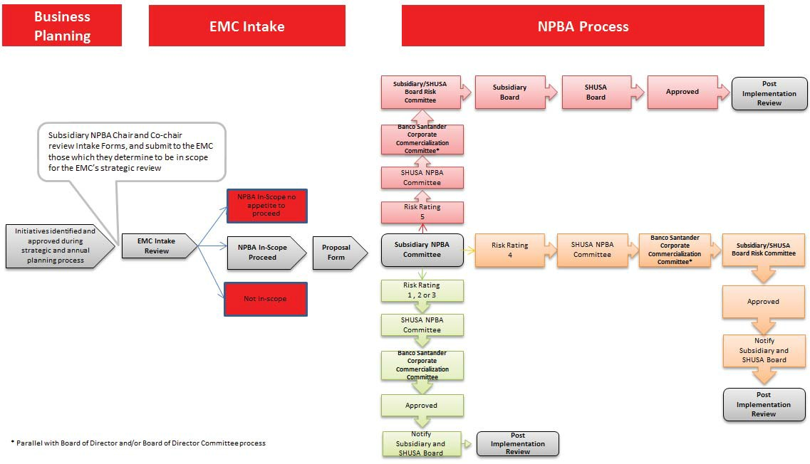

The Proponent will present an assessment of the initiative to the subsidiary’s EMC. The subsidiary’s EMC will determine whether the initiative fits within the definition of a new product or business activity, and if so, whether it should be considered, based on alignment with the subsidiary’s strategic and financial objectives and expressed risk tolerance.

Date Last Approved June 2015 Version Number 2

The NPBA Coordinator will coordinate the NPBA process and provide guidance to the Proponent in developing the NPBA Proposal and completing all the necessary due diligence and risk assessment activities. The Proponent is responsible for coordinating reviews as required in the Proposal Form; participants in the NPBA Proposal Form diligence process are referred to as the Development Team. The NPBA Coordinator provides reporting to the Regulatory Affairs Office.

The subsidiary’s NPBA Committee will review the Proposal, and may either recommend approval, approval with condition, or reject the Proposal. The subsidiary NPBA Committee will recommend an overall risk rating of the Proposal to the SHUSA NPBA Committee.

The SHUSA NPBA Committee will review the recommendation from the subsidiary NPBA Committee, and may confirm the recommendation of the subsidiary NPBA Committee, challenge or impose the conditions or risk rating, or reject the Proposal. Proposals that are recommended for approval or approval with condition are then submitted to the Banco Santander Corporate Commercialization Committee. The SHUSA NPBA Committee will also review and consolidate reports from the subsidiary NPBA Committees on NPBA pipelines and post-implementation performance activities.

The SHUSA Board will provide oversight of the overall NPBA process. In connection with its oversight, the SHUSA Board will review quarterly reports from the SHUSA NPBA Committee.

The final approval process correlates to the overall risk rating of the Proposal.

5 High

4 Elevated

* Approval is provided from the SHUSA Board of Directors, following the subsidiary Board of Directors;
* Subsidiary and SHUSA Board Risk Committee recommendation for approval;
* Banco Santander Corporate Commercialization Committee approval (if required);
* Subsidiary and SHUSA NPBA Committees recommendation for approval.
* The subsidiary and SHUSA Boards of Directors are notified of the Proposal.
* Approval is provided from the subsidiary and SHUSA Board Risk Committees;
* Banco Santander Corporate Commercialization Committee approval (if required);
* Recommendation for approval from the subsidiary and SHUSA NPBA Committees.

3 Moderate • The subsidiary and SHUSA Boards of Directors are notified of the Proposal;

2 Low-Mod

1

Low

* Banco Santander Corporate Commercialization Committee approval (if required);
* Approval provided from the SHUSA NPBA Committee;
* Recommendation for approval by the subsidiary NPBA Committee.

### Review and Approval Process

#### Identification

The identification of NPBAs that will enter the review and approval process includes the following steps:

* + - * Determining whether a proposed initiative should be subject to the NPBA review and approval process based on the definition of “NPBA” set forth in this Policy; and

Date Last Approved June 2015 Version Number 2

* + - * Evaluating whether the organization should pursue the proposed NPBA1 on the basis of its alignment with the organization’s strategic and financial objectives, and expressed risk tolerance.

The subsidiary EMCs are responsible for determining whether a proposed initiative should be subject to the NPBA review and approval process. The subsidiary EMC may delegate this task to the Chair and/or Co-chair of the subsidiary NPBA Committee as appropriate. Initiatives that are determined to be within the NPBA scope and within the subsidiaries appetite will proceed to complete the NPBA Proposal Form (“Proposal”), which includes a risk assessment.

#### Due Diligence

The Proponent, with assistance from the NPBA Development Team, will conduct due diligence to ensure SHUSA and its subsidiaries have a thorough understanding of the characteristics of the proposed NPBA, as well as the regulatory and non-regulatory requirements associated with its introduction. The due diligence process includes the following activities:

* + - * Documenting the rationale for developing the proposed NPBA, which should include an explanation of whether, and how, the NPBA fits within or deviates from the approved business strategy and risk profile;
      * Evaluating the impact of the proposed NPBA on the current and potential customer base;
      * Determining the requirements for complying with applicable laws, regulations, and regulatory guidance;
      * Determining the expertise and staffing levels needed to effectively manage the proposed NPBA, including the need to acquire additional expertise;
      * Conducting a training needs assessment and preparing a plan to train personnel involved in the management and distribution of the proposed NPBA for implementation prior to launch;
      * Identifying any capital and operational needs, including new or enhanced technology, necessary to implement the proposed NPBA, and assessing the operational readiness of the organization prior to launch;
      * Developing a business and financial plan for bringing the proposed NPBA to market;

1. Products, services, and activities that are described in the strategic plan approved by the subsidiary EMC will be considered for development and analysis under the NPBA process. The subsidiary EMC will review other potential NPBAs that arise outside of the strategic planning cycle on ad hoc basis.

Date Last Approved June 2015 Version Number 2

* + Ensuring that third-party providers involved in the development and implementation of the proposed NPBA have been evaluated and approved in accordance with applicable regulatory requirements and internal standards;
  + Identifying and reviewing any models associated with the implementation of the proposed NPBA and ensuring they have been approved and validated in accordance with applicable supervisory expectations and internal standards;
  + Developing a plan for monitoring and reporting on the actual performance of the proposed NPBA against pre-determined projections and metrics, and test the adequacy and effectiveness of controls; and
  + Developing viable alternatives, including an exit strategy, in the event the proposed NPBA fails to perform as expected.

#### Risk Assessment

The Proponent will conduct a risk assessment to identify the risks posed by the proposed NPBA and evaluate the strength of the control environment.2 The Proponent will consider each of the risk areas identified in the SHUSA ERM Framework and metrics included in the SHUSA Risk Appetite Statement and adhere to the standards established in the SHUSA Risk Identification and Assessment Policy when conducting the risk assessment.

The relevant control and oversight functions comprising the NPBA Development Team, including the applicable risk disciplines (e.g., Compliance, Liquidity Risk, Credit Risk, Operational Risk), will oversee the Proponent’s risk assessment and challenge the results of the risk assessment. The subsidiary NPBA Committee will review the risk assessment performed by the NPBA Development Team and may use the results of the risk assessment, as part of the holistic Proposal, to determine the overall risk level of the proposed NPBA. The SHUSA NPBA Committee will review the determination of the overall risk level of the proposed NPBA, and will evaluate the adequacy of the due diligence performed.

#### Recommendation and Approval

SBNA or SCUSA will not launch any NPBA without all the approvals, as described below.

1. The Proponent is responsible for identifying risks, assigning inherent risk ratings, and evaluating the control environment. The relevant control and oversight functions are responsible for reviewing and challenging the Proponent’s evaluation of the inherent risks and the control environment as well as assessing the quality of risk management. The Proponent combines the results of this analysis into the NPBA Risk Assessment Template to determine the residual risk ratings. For a more detailed description of the NPBA risk assessment process, see the *SBNA and SCUSA NPBA Procedures.*

Date Last Approved June 2015 Version Number 2

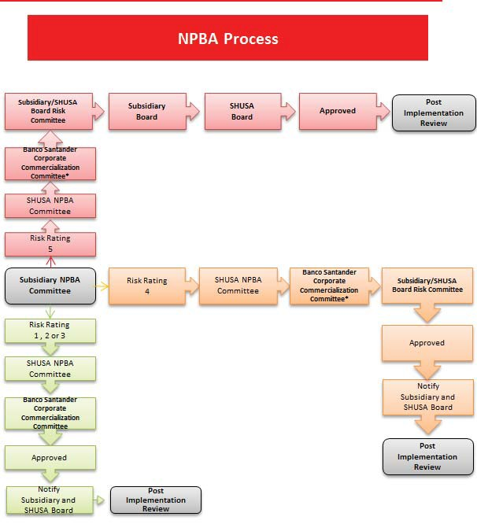

#### Launch

Prior to launching an approved NPBA, the NPBA Development Team, or other designated team, will develop appropriate risk management controls and processes for:

* + - * Training personnel responsible for implementing and administering the approved NPBA;

Date Last Approved June 2015 Version Number 2

* + - * Developing new, or amending existing, risk management policies and procedures to ensure the NPBA is adequately addressed, as proposed in the identification of required controls in the risk assessment phase; and
      * Capturing the NPBA in existing risk management, compliance, and internal audit processes.

#### Monitoring and Reporting

The Proponent will propose monitoring plans for the NPBA, including protocols for addressing identified risk trends and concerns, altering business plans, and adopting exit strategies and will report to the subsidiary NPBA Committee per the Plan’s provisions.

Following the launch of a NPBA, the line of business responsible for the NPBA will monitor actual product performance, including, but not limited to, customer service metrics (e.g., consumer complaints and inquiries, quality control reviews of customer calls), financial performance, the number of new customers, controls or operational issues and remedial activities, effectiveness of controls, and any other metric identified by the NPBA Committee, subsidiary Board, SHUSA Board, or Group CCC. The line of business will provide ongoing reports of post-launch performance information to the subsidiary NPBA Committee. The duration and frequency of reporting will be determined in the monitoring plans, and will take into consideration the risk profile of the NPBA and any approval requirements. The subsidiary NPBA Committee will develop NPBA management information for the subsidiary boards and the SHUSA NPBA Committee. The SHUSA NPBA Committee will review and consolidate information from the subsidiary NPBA Committees and provide to the SHUSA Board or committee thereof. More frequent ad- hoc information may be requested if necessary or desirable.

### Issue Management/Escalation

The Proponent must report material issues3 that arise in conjunction with the introduction of a NPBA in a timely manner to the appropriate subsidiary NPBA Committee. The Proponent must develop a remediation plan acceptable to the subsidiary NPBA Committee and report progress against the plan.

### Training

The Proponent will develop a training plan that will be implemented and completed prior to the launch of the NPBA. The training plan should include sufficient detail to satisfy the relevant approval bodies at the subsidiary and SHUSA level that personnel involved in the distribution of the proposed NPBA will be

3 Material issues include, for example, the ineffectiveness of risk management controls.

Date Last Approved June 2015 Version Number 2

fully versed in its features, regulatory requirements, and in the procedures developed to guide the performance of their responsibilities.

## Reporting Structure

The NPBA process reporting structure is shown in the following diagram:

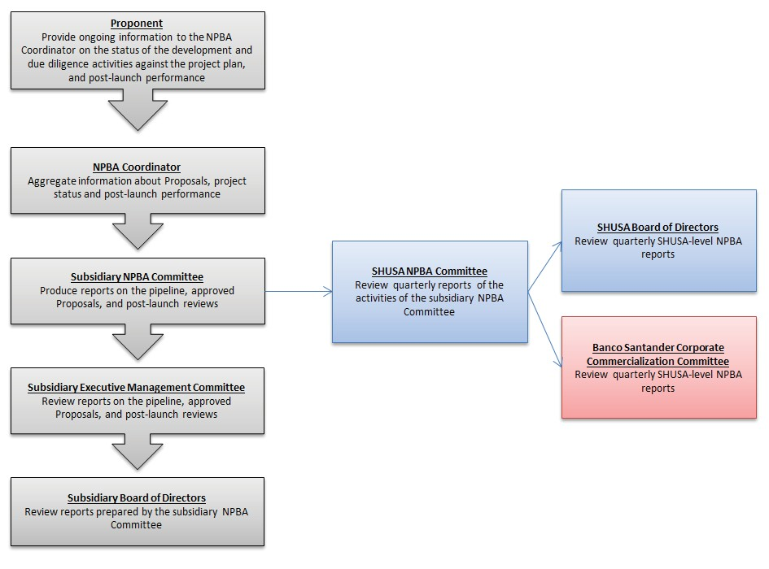

## Roles and Responsibilities

### Three Lines of Defense

As described in the SHUSA ERM Framework, SHUSA has established a “three lines of defense” model to organize the roles and responsibilities of the critical parties involved in the identification, review, and approval of NPBAs. This model includes the following:

* + - The first line of defense consists of risk-taking functions (lines of business) and corporate functions (or support units), such as Finance and IT.
    - The second line of defense consists of Risk Management, Risk Consolidation, and Compliance.
    - The third line of defense consists of Internal Audit.

Refer to the SHUSA ERM Framework for a complete definition of the model and the roles and responsibilities for each of the three lines of defense.

Date Last Approved June 2015 Version Number 2

### NPBA Roles and Responsibilities

Outlined below are the responsibilities of the relevant parties involved in the management and oversight of the risks associated with the introduction of NPBAs.

|  |  |
| --- | --- |
| **NPBA Roles and Responsibilities** | |
| Banco Santander Corporate Commercialization Committee | The Group CCC is responsible for reviewing all NPBAs proposed by  SHUSA and its subsidiaries and providing their approval. The Group CCC reviews quarterly reports prepared by the SHUSA NPBA Committee with respect to the NPBA pipeline of its subsidiaries. |
| SHUSA Board of Directors | The SHUSA Board is responsible for reviewing and approving, or  rejecting, all Proposals risk rated as “high” risk. The SHUSA Board is notified of all other Proposals. The SHUSA Board ensures SHUSA’s subsidiaries effectively adopt and implement the Policy and receives quarterly reports prepared by the SHUSA NPBA Committee. |
| SHUSA and subsidiary Board Risk  Committees | The SHUSA and subsidiaries Board Risk Committees are responsible  for reviewing and recommending approval or rejecting all Proposals risk rated as “elevated” risk. |
| SHUSA NPBA Committee | The SHUSA NPBA Committee is responsible for reviewing and  recommending for approval, approving, or rejecting, proposed NPBAs to the Group CCC and overseeing the approval process, including post-launch monitoring, to ensure compliance with applicable regulatory guidance as well as enterprise-wide standards. The SHUSA NPBA Committee prepares quarterly reports on the subsidiary NPBA activities for distribution to the SHUSA Board, and the Group CCC. Approval for Proposals risk rated as “low”, “low-to moderate”, or “moderate” receive approval at the SHUSA NPBA Committee subject to CCC approval. |
| Subsidiary Board | The subsidiary board ensures the subsidiary effectively adopts and  implements the NPBA Policy. The subsidiary board receives quarterly reports on its NPBA activities. |

Date Last Approved June 2015 Version Number 2

|  |  |
| --- | --- |
| **NPBA Roles and Responsibilities** | |
| Subsidiary NPBA Committee | The subsidiary NPBA Committee is responsible for reviewing and  recommending for approval, or rejecting, proposed NPBAs to the SHUSA NPBA Committee and overseeing the approval process, including post-launch monitoring, to ensure compliance with applicable regulatory guidance as well as enterprise-wide standards. |
| Subsidiary Executive Management Committee | The EMC is responsible for determining: (i) whether a proposed  initiative meets the definition of “NPBA” set forth in this Policy; and, if so, (ii) which NPBAs should enter the NPBA review and approval process. |
| Chief Legal Officer | The SHUSA CLO is responsible for vice chairing the SHUSA NPBA  Committee. |
| NPBA Coordinator | The NPBA Coordinator is responsible for owning, designing, and  managing the SHUSA NPBA review and approval process. |
| Chief Risk Officer | The SHUSA CRO is responsible for chairing the SHUSA NPBA  Committee and defining and overseeing the implementation of the process that will help the organization identify and assess the risks associated with the introduction of proposed NPBAs. |
| Risk Management and Compliance | The Risk Management function and the Compliance function are  responsible for reviewing and challenging the risk assessment analysis prepared by the Proponent and ensuring that the Proponent has satisfied all applicable conditions and requirements before presentation to the subsidiary NPBA Committee. |
| Lines of Business | The lines of business are typically the Proponents of NPBA  Proposals and are responsible for developing NPBA Proposals, seeking the required approvals, and satisfying applicable pre- and post-approval requirements, including requirements regarding performance monitoring, testing, and reporting. |

Date Last Approved June 2015 Version Number 2

|  |  |
| --- | --- |
| **NPBA Roles and Responsibilities** | |
| NPBA Development Team | The NPBA Development Teams are cross-functional teams  including representatives from the applicable risk disciplines, including Compliance, and corporate functions (e.g., IT, Operations, Legal, Human Resources, Treasury, and Finance). The NPBA Development Teams are responsible for assisting the Proponent in developing the diligence materials and performing the risk assessment. |
| Internal Audit | Internal Audit is responsible for conducting independent reviews of  the NPBA process, and performing product post-launch reviews, audits, and testing. Internal Audit participates in the NPBA process for purposes of providing robust analysis and challenge of due diligence and risk assessment processes. Internal Audit will attend the meetings of the NPBA Committee as an observer and will not approve or endorse the approval of any NPBA. |

Date Last Approved June 2015 Version Number 2

## Exceptions

There are no exceptions to this Policy.

## Non-Compliance

All lines of business, control and oversight functions, and support units at SHUSA and its subsidiaries are responsible for complying with this Policy. Non-compliance with the Policy may result in a violation of the SHUSA Code of Conduct and Ethics. Senior management across the organization is responsible for ensuring adherence to the Policy and taking appropriate action in case of non-compliance.

## Document History and Version Control

### Ownership and Authorship

|  |  |  |  |  |
| --- | --- | --- | --- | --- |
| Version | Date | Author | Owner | Reason for Change |
| 1 | 11/6/14 | SHUSA CLO | SHUSA CLO | Initial Version |
| 2 | 6/26/15 | SHUSA NPBA  Coordinator | SHUSA CRO | Updates to approval process to  correlate to risk rating; other administrative changes |
|  |  |  |  |  |
|  |  |  |  |  |
|  |  |  |  |  |
|  |  |  |  |  |
|  |  |  |  |  |
|  |  |  |  |  |

### Sign off

|  |  |  |
| --- | --- | --- |
| Approving Body | Governance Committee Approval | Final Approval  Date |
| SHUSA Board of Directors | SHUSA Executive Management Committee | 11/6/14 |
| SHUSA Board of Directors | SHUSA Executive Management Committee | 06/26/15 |
|  |  |  |
|  |  |  |

Date Last Approved June 2015 Version Number 2

## Appendices4

### Appendix A. Laws and Regulations

For purposes of the Policy, “laws and regulations” define the legal and regulatory requirements that apply to SHUSA’s operations, including but not limited to:

* Applicable U.S. laws.
* Rules, regulations, guidelines, standards, directives, and interpretations issued by the Board of Governors of the Federal Reserve System (“FRB”) and state and local jurisdictions.
* Agreements or understandings reached with SHUSA’s regulatory bodies.
* Federal Accounting Standards that govern the preparation of financial reports.

#### Key Laws, Regulations, and Regulatory Guidance

* FRB, Enhanced Prudential Standards for Bank Holding Companies and Foreign Banking Organizations (March 27, 2014).
* Office of the Comptroller of the Currency, Risk Management of New, Expanded, or Modified Bank Products and Services, Bulletin 2004-20 (May 10, 2004).

### Appendix B. Related Policies, Procedures, and Other Documents

* SHUSA ERM Framework
* SHUSA Enterprise Risk ID and Assessment Policy
* SHUSA Enterprise Third Party Provider Risk Management Policy
* SHUSA NPBA Procedures
* SHUSA Code of Conduct and Ethics

4 Please refer to the NPBA User Guide for a list of key contacts.